**State of the Art and Existing Designs**

In this section we will discuss a state of the art design manufactured by a medical technology company as well as designs made by laypeople. Medical device companies have the resources to design prosthetics that can be used for human use. Our focus will be on simpler models not meant as prosthetics that are easy to make and affordable.

Medical device companies have made great strides in the prosthesis field. One such company is RSLSteeper. This company has created the bebionic hand, a myoelectric prosthesis. The most current product, the bebionic3, uses sensors placed on the skin to pick up impulses from muscle tissue to control the hand. It has individual motors for each finger which are positioned to optimize weight distribution. The hand features proportional speed control so the hand can perform delicate tasks as well as handling up to 45 kilograms. The prosthesis is designed to mimic a human hand and move as naturally as possible. The bebionic3 is one of several state-of-the-art prosthetics on the market today. Others include the iLimb by touch bionics, costing about ___ and the Michelangelo by Ottobock, costing about ____. The iLimb and Michelangelo use similar technology to the bebionic3. I’d talk about the price and maybe also the weight of the bebionic, I’d also talk about at least one other professional level hand because hey why not (or at the very least say that there are these other competitors each costing about X much). I didn’t want to talk too much about human prosthetics because that’s not what our projects is about. Also, where would I find prices?

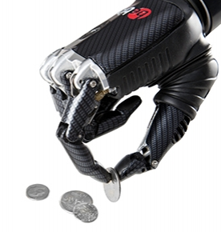

Figure 1: bebionic hand

Next we will discuss hands made by laypeople. These hands were designed and manufactured by people with limited resources. Because of that, the hands are simple and affordable. They set a precedent for inexpensive 3D printed hands. Why are we discussing them? Because they set a precedent for affordable 3d printed hands. Maybe mention that so it becomes clear that we’re building on that technology, rather than doing something totally novel (which would probably be too ambitious for a senior design project) The RoboHand was designed by Richard Van As, a man from South Africa who lost his fingers in an industrial accident. He used a MakerBot 3D printer and created the design on CAD software. The entire assembly is composed of 3D printed parts, with the exception of three components. The hand has a very simplistic design using a system of cables. When the user bends his wrist down, the cables effectively shorten, causing the fingers to curl into a grasping position. When the user bends his wrist up, the hand opens and the fingers release. Although the hand is not medically sanctioned, Richard has used this design to help children suffering from amniotic band syndrome.

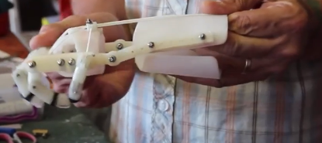

Figure 2: Wrist bent down, fingers grasping.

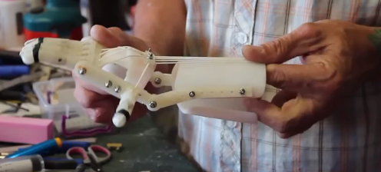

Figure 3: Wrist bent up, grip released.

Another hand that has been created using a 3D printer is called the InMoov. This is a robotic hand not meant as a prosthetic. The hand moves using motors attached to cables on the inside and outside of each finger. When the motor tightens the cables on the inside, the fingers curl in. When the motor releases the inside cables and tightens the cables on the outside, the fingers open. I would actually go into a little depth on how it works: i.e. it uses a system of cables attached to motors, and how that works exactly to pull fingers in, that way our design kind of naturally follows from this one and sounds less out-of-left-field and is controlled using electrodes attached to the skin that pick up impulses from the muscles, much the like the bebionic3. When the user opens and closes his hand, the robot mimics his actions. Examples of this can be seen in the images below

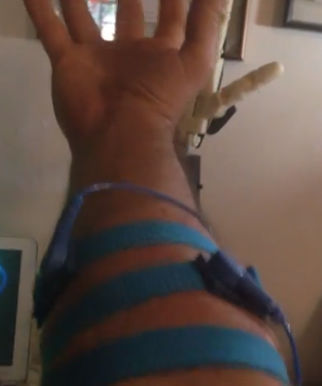

Figure 4: Electrodes attached to the users arm

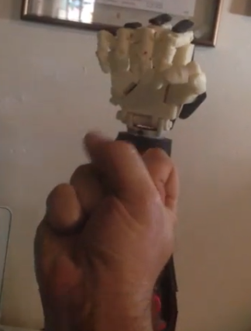 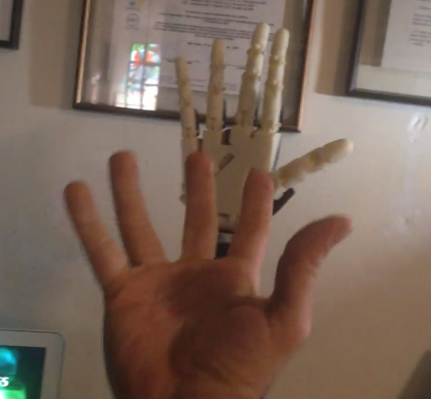

Figure 5: Robot closes fist when user closes fist Figure 6: Robot opens hand when user opens hand

The next topic we will discuss is granular jamming. Research has shown that granules enclosed in a flexible casing are soft and pliable, and can mold around objects. However, when the air is removed, it becomes hard and rigid. Currently this technology is going to be used for robots on assembly lines to help pick up objects, but our team wants to integrate this technology into a robotic hand. A pictorial explanation of granular jamming is provided below. I’d flesh this out a little more but I don’t know if it is your responsibility to or not. If you want you can talk about it more or maybe I can look into it myself. I believe Chris Wallace was doing something on how it actually works. I was trying to go for more functionality and how it can be used

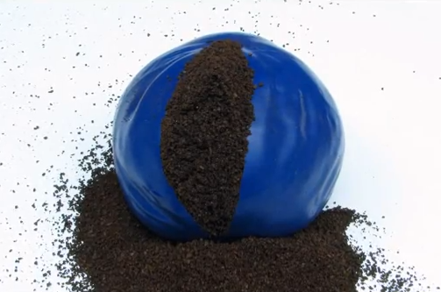 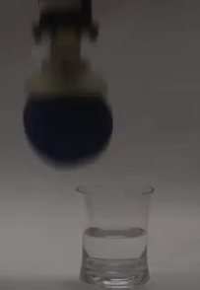

A flexible casing is filled with granules The casing is placed on the end of a robotic arm

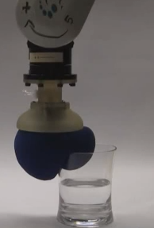 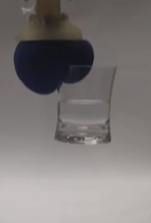

The casing is placed on an Now that the granules are rigid,

object and the air is removed. the robot can pick up the object

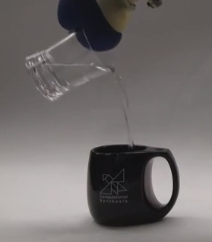 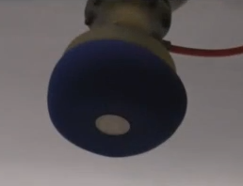

The object is held securely The robot can now do tasks that are difficult for humans, such as picking up a coin off of a flat surface